Observations & Inferences
Name ____________________________________

Part 1: Qualitative vs. Quantitative observations

Which type of observations are these? __________________________________
List 3 descriptions for each sense.

Looks like | Smells like | Feels like | Sounds like | Tastes like

Which type of observations are these? ___________________________________
(Remember correct UNITS!!! Use the Metric System!!!)

Mass | Volume | Density | Diameter | Circumference

PART II: Beside the picture, write a detailed account of what happened in the cartoon. Describe the scenario using a minimum of 5 complete sentences.

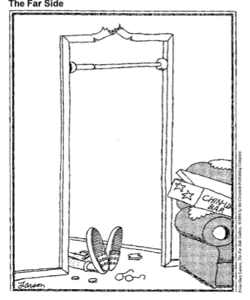

- Read the definitions below:
-Observation: the act of seeing an object or an event and noting the physical characteristics or points in the event. Observation is an extension of our senses—what is seen, smelled, tasted, heard, and touched.

-Inference: conclusions based on observations. Inferences go beyond what we directly sense.

- Read the account you wrote beside the Far Side cartoon.
Underline all the observations once. Underline the inferences twice.

- Place an “O” next to observation and an “I” next to inference. Then write your own for the final two blanks.

_____ The time of day in the cartoon is unknown.
O: ______________________________________________________________________

I: ______________________________________________________________________
_____ The person is wearing shoes and socks.
_____ The person pictured is a man.
_____ The chin-up bar is set too high.
_____ The chin-up bar arrived in one package.
_____ The person pictured has less than 20/20 eyesight.
_____ The person is lying on their back.
_____ The person has sustained an injury.
_____ The frame of the glasses is bent.
_____ This was the first time the person used a chin-up bar.

- Scientists make inferences as they attempt to develop answers to questions about natural phenomena. Even though their answers are consistent with the evidence available, often no single answer or story solely accounts for that evidence. Nevertheless, as with the case of this cartoon, some inferences are better supported by multiple observations.

Create 3 different inferences to explain why the person is lying on the ground. For each inference, provide one piece of supporting evidence.

Inference: __________________________________________________________________________________________________

Evidence: __________________________________________________________________________________________________

Inference: __________________________________________________________________________________________________

Evidence: __________________________________________________________________________________________________

Inference: __________________________________________________________________________________________________

Evidence: ____________________________________________________________________________________________________

- Indicate which inference is most plausible by marking a star next to it.

- What additional evidence exists in the cartoon to support this inference?

