Name ______________________________________________
Period _____ Date _______________

Name the 6 Kingdoms of Organisms: ________________________________________________________________________________________

Nine Major Phyla of Animals
1. Poriferans (sponges)

2. Cnidarians (jellyfish)

3. Flatworms/Platyhelminthes
(tapeworms)

4. Roundworms/Nematoda
(heartworm)

5. Annelids/Segmented worm
(earthworm)

6. Mollusks (clam)

7. Arthropod (grasshopper)

8. Echinoderm (starfish)

9. Chordate (human)
more complex
invertebrates
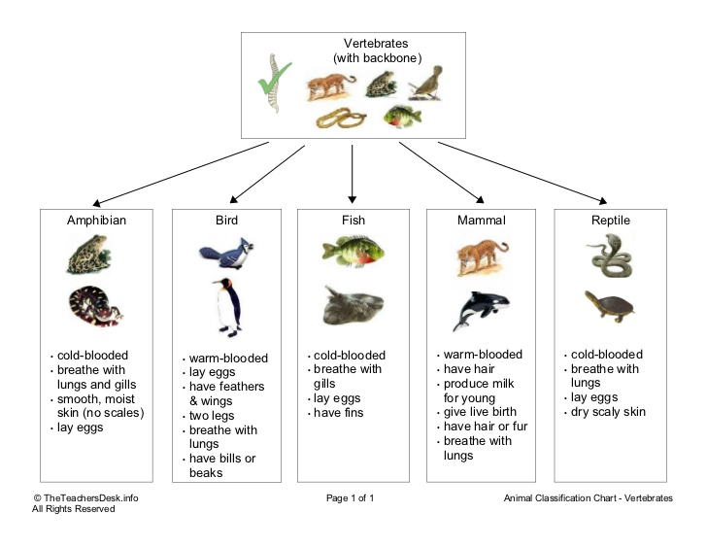

9. Chordates (humans)

Name the correct Phylum (all are Kingdom Animalia)
1. soft bodied animals that usually have a shell: _________________________ 2. soft, thin, flat body: ____________________________
3. jelly-like animals that have a bell or umbrella shape: ____________________ 4. internal spine that supports the body: _____________________
5. long animals divided into segments: _______________________________
6. 3 main body parts, jointed legs, and a tough exoskeleton: __________________________
7. marine animals that have plates with spines and usually 5 legs: ________________________
8. asymmetrical body, no distinct tissues or organs, saclike and porous body ____________________________________

Name the correct Class (all are Phylum Chordata)
1. Iguanas, crocodiles, boa constrictors: _______________________________ 2. Sparrows, swallows, finches: ___________________________
3. Salamander, tree frog, toad, newt: __________________________________ 3. Dolphin, hamster, polar bear, tiger: ______________________
5. Sardine, perch, herring, pike, bass, carp: _____________________________ 6. Chameleon, turtle, lizard: _____________________________
7. cold blooded, breathe with lungs and gills, smooth moist skin: ___________________
8. have hair, breathe with lungs, warm blooded, produce milk: ______________________
9. cold blooded, breathe with gills only: _____________________ 10. Cold blooded, breathe with lungs, scaly skin: ______________________
Name the Taxonomic Category:

K _______________ P _______________ C________________ O________________ F______________ G ______________ S______________
Make up your Own Acronym! (Mine is: King Philip Came Over For Ginger Snaps)

K _______________ P _______________ C________________ O________________ F______________ G ______________ S______________

