Name _____________________
Period __________
Work and Simple Machines Notes
What is WORK?
- Work is done when a _____________ causes an object to ___________ in the same ______________ that the force is applied.
- The formula for work is: _____________ = ____________ X ____________________
- If there is no _______________________, there is no _____________ being done!!
When is “work” being done?
- A _______________must applied to an object (called “effort force” or input)
- The object must move in the _________________________________ as the force.
What is purpose of a machine?
- To make work seem __________________!
How do machines make work “easier”?
- They can change the amount of _______________ required.
- They can change the ______________ the object has to move.
- They can also change the __________________ (allowing you to work WITH gravity rather than against it)
- Any change in the size of the force changes the distance. No machine can increase both force and distance. This is an ______________________ relationship.
- If you increase _____________you decrease distance. (W = F x D)
- If you increase ______________ you decrease force required. (W = F x D)
- Or, leave force and distance alone but change the _________________ that the load moves. (Use gravity!)
Units to Know:
Work is measured in __________________________
Force is measured in __________________________
Distance is measured in _______________________

What is mechanical advantage?
- The number of times a machine _________________ the effort force.
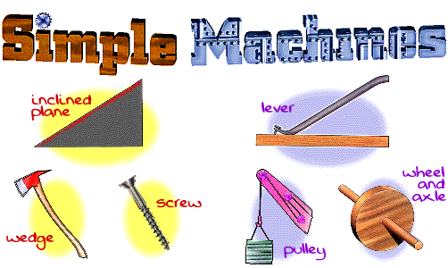
Four types of simple machines
    - the ________________
    - the ________________
    - The ___________________________________
    - The _________________________
LEVER:
a simple machine made with a rigid bar free to _____________ (move) around a fixed point called a _________________
PULLEY:
A simple machine made with a rope, belt or chain wrapped around a grooved _______________, a pulley works two ways. (changing __________________ or amount of force)
WHEEL and AXLE:
large ________________ rigidly secured to smaller wheel, called the axle
**INCLINED PLANE:
A simple machine with no moving parts, it is simply a straight slanted surface. (ex: a ramp)
IT INCREASES THE DISTANCE TRAVELED, but REQUIRES LESS FORCE FROM YOU!!!
- Formula for mechanical advantage:_______________________________________
- Other types of inclined planes:
  - ____________: separating or holding device
  - ____________: circular inclined plane
Final THOUGHT: WORK always stays ____________________________ with or without a simple machine!
- Whether you use a machine or not, the TOTAL WORK done stays the same.
- What would increase/decrease? ____________________ or _________________________

